Report view:

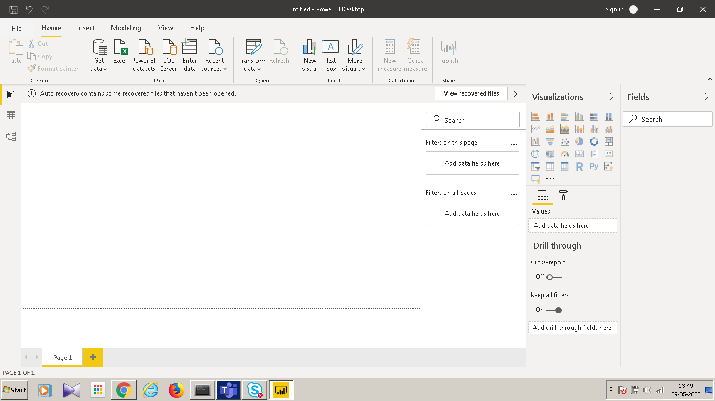

Data view:

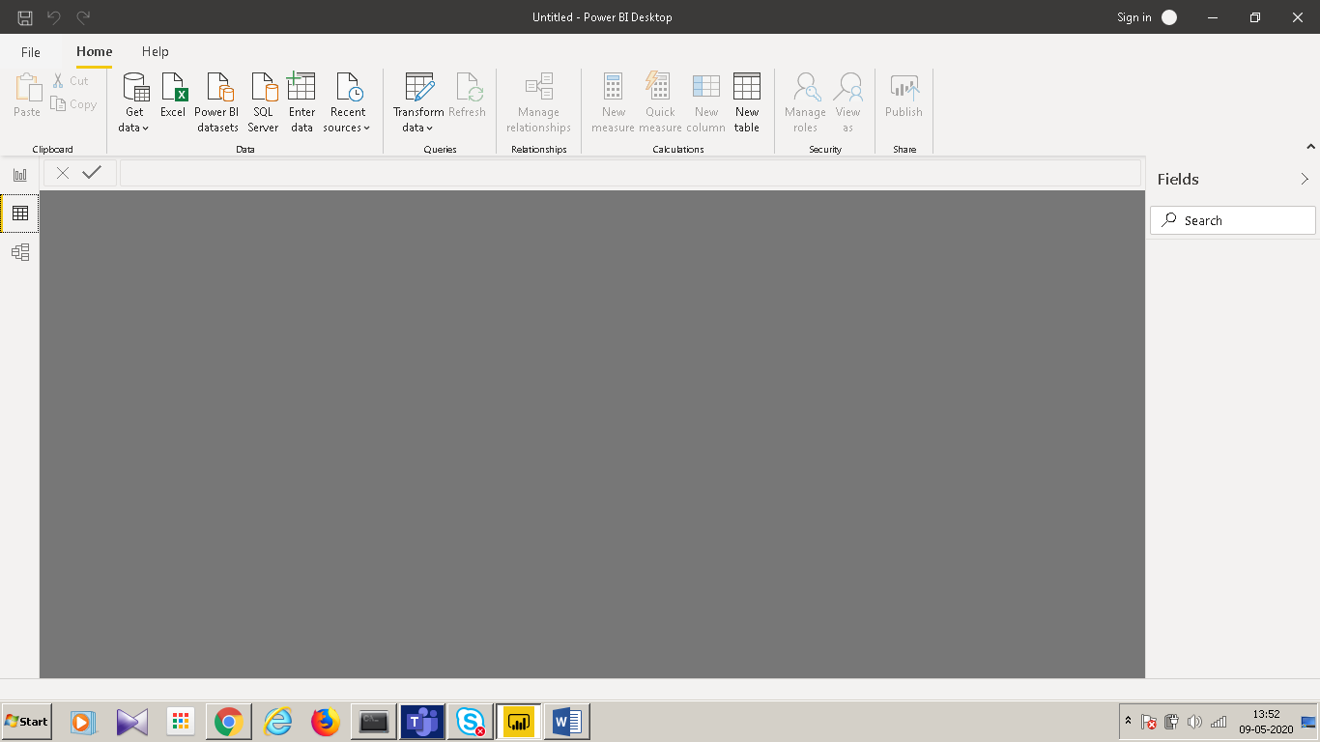

Model view:

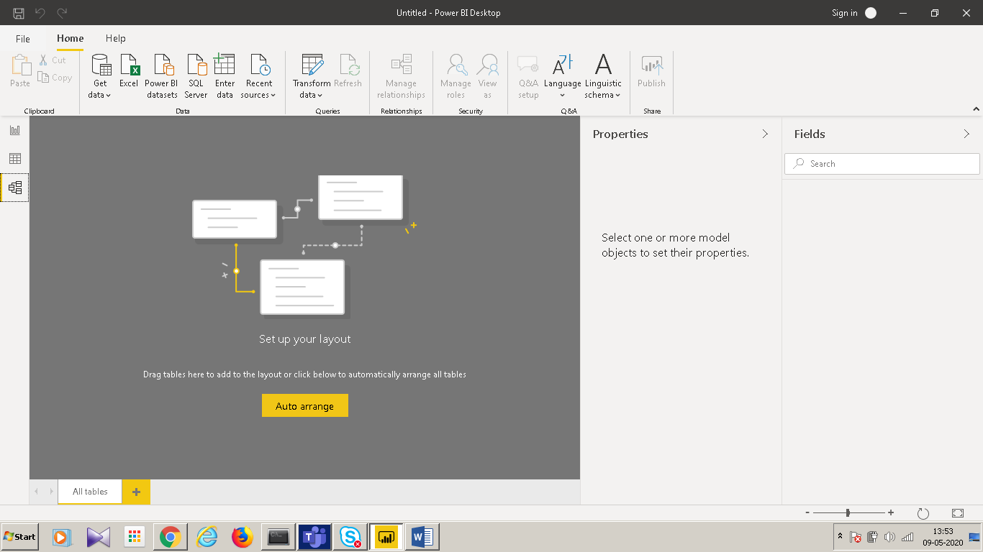

Power Query editor:

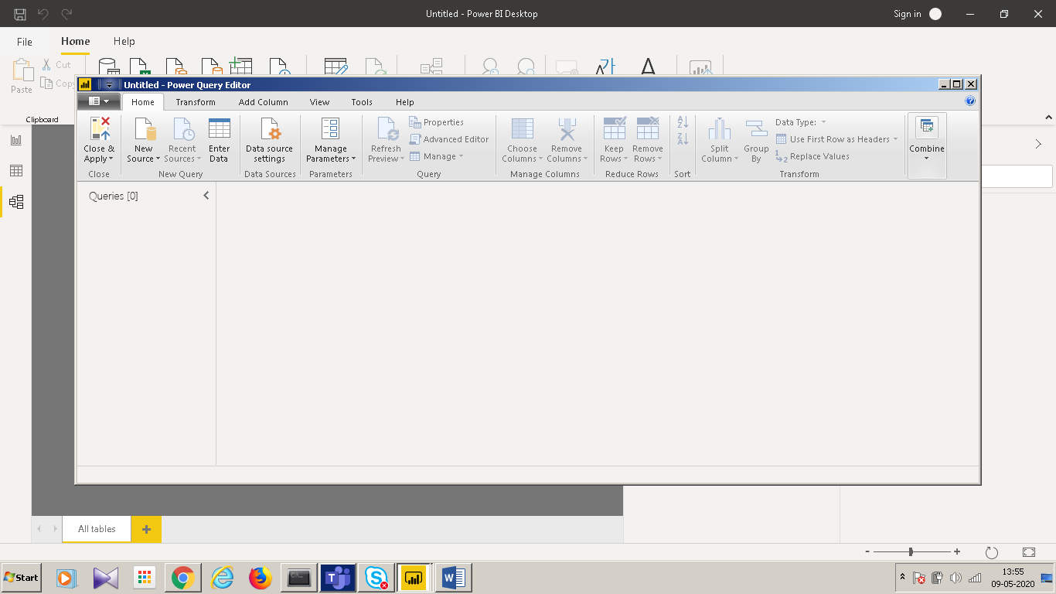

Advance editor:

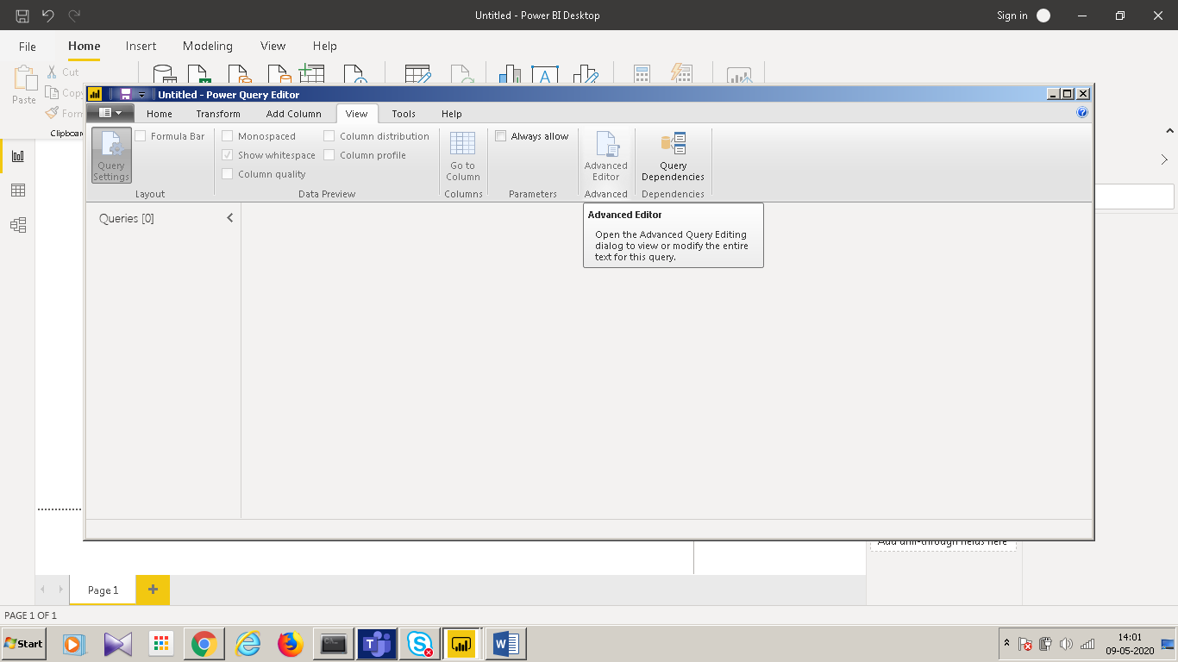

Pricing:

Power BI Desktop-> Free

Power BI pro-> $9.9 Monthly price per user

Power BI premium-> $4995 Monthly price per dedicated cloud compute and storage resource with annual subscription